Name:

1. (10) Suppose P(x,y) is a predicate and the universe for the variables x and y is {1,2,3}. Suppose P(1,3), P(2,1), P(2,2), P(2,3), P(3,1), P(3,2) are true, and P(x,y) is false otherwise. Determine whether the following statements are true.

a. ¬∃x∃y(P(x,y) ∧ ¬P(y,x)).

b. ∀x∀y (x ≠ y → (P(x,y) ∨ P(y,x)).

2. (10) Determine whether (q ∧ (p → ¬q)) → ¬p is a tautology.

3. (12) In the questions below, suppose A = {a,b,c} and B = {b,{c}}. Mark the statement TRUE or FALSE

a. | P(A × B) | = 64.

b. ∅ ∈ P(B).

c. B ⊆ A.

d. {a,b} ∈ A × A.

e. {b,c} ∈ P(A).

f. ∅ ⊆ A × A.

4. (10) Suppose f : R → Z where f(x) = ⎡2x − 1⎤.

(a) Is f 1-1?
(b) Is f onto Z?

5. (20) Use the Principle of Mathematical Induction to prove that 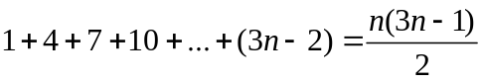 for all n ≥ 1.

6. (10) How many bit strings of length 10 have exactly six 0s?

7. (10) In the questions below determine whether the binary relation is: (1) reflexive, (2) symmetric, (3) anti-symmetric, (4) transitive.

a. The relation R on Z where aRb means a² = b².

b. The relation R on Z where aRb means | a − b | ≤ 1.

8. (6) Find the matrix that represents the given relation R on {−2,−1,0,1,2,} where aRb means a² = b².. Use elements in the order given to determine rows and columns of the matrix.

9. (12) Consider the following theorem: If x is an odd integer, then x + 2 is odd. Give a proof by contradiction of this theorem.

Solutions

1.
a. Ans : False

b. Ans : True

2.
Ans: Yes

3
- Ans: True
- Ans: True
- Ans: False
- Ans: False
- Ans: True
- Ans: True

4
- Ans: No
- Ans: Yes

5
Ans: P(1): 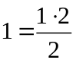 , which is true since 1 = 1. P(k) → P(k + 1): 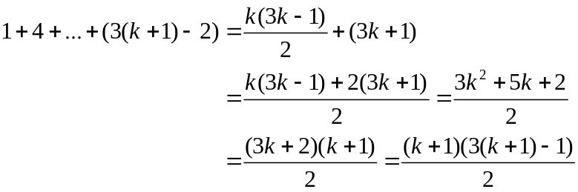

6
Ans: C(10,6)

7
- Ans: 1,2, 4
- Ans: 1, 2

8
Ans: 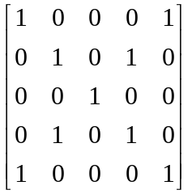.

9

Ans: Suppose x is odd but x + 2 is even. Therefore x = 2k + 1 and x + 2 = 2l. Hence (2k + 1) + 2 = 2l. Therefore 2(k + 1 − l) = −1 (even = odd), a contradiction.

